**Q 1. Write an assembly language program to perform addition of 8-bit data.**

CODE:

num1 db 23h

num2 db 25h

start:

mov al, num1

add al, num2

mov bl, al

mov al, bl

shr al, 4

and al, 0Fh

add al, 30h

cmp al, 39h

jle print_digit1

add al, 7

print_digit1:

mov dl, al

mov ah, 02h

int 21h

mov al, bl

and al, 0Fh

add al, 30h

cmp al, 39h

jle print_digit2

add al, 7

print_digit2:

mov dl, al

mov ah, 02h

int 21h

mov ah, 4Ch

int 21h

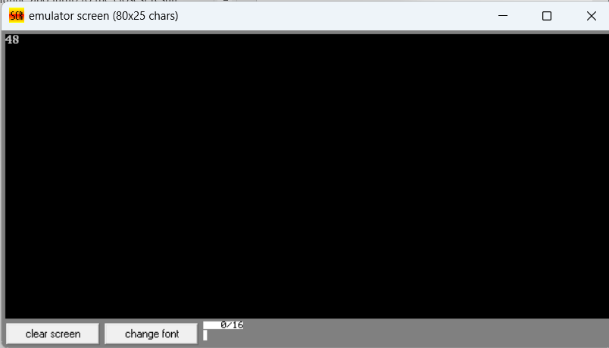

**Q 2. Write a program in assembly language to perform addition of 16-bit data.**

CODE:

org 100h

jmp start

num1 dw 123

num2 dw 15

msg db 'Result: $'

newline db 0Dh, 0Ah, '$'

start:

mov ax, [num1]

add ax, [num2]

call PrintNumber16

mov dx, offset newline

mov ah, 09h

int 21h

mov ah, 4Ch

int 21h

PrintNumber16 proc

cmp ax, 0

jne PrintDigits

mov dl, '0'

mov ah, 02h

int 21h

ret

PrintDigits:

mov cx, 0

mov bx, 10

PrintLoop:

xor dx, dx

div bx

push dx

inc cx

test ax, ax

jnz PrintLoop

PrintStack:

pop dx

add dl, '0'

mov ah, 02h

int 21h

loop PrintStack

ret

PrintNumber16 endp

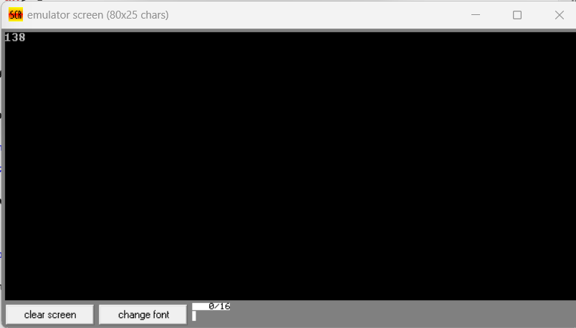

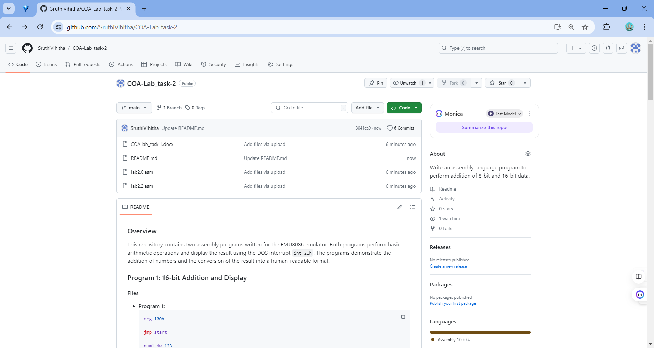

Git hub Repository link: <https://github.com/SruthiVihitha/COA-Lab_task-2.git>